Accessing your leave balances

- Log into ctcLink
- Click the HCM-Self Service Tile
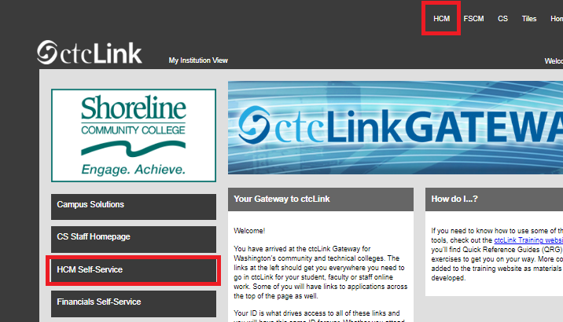
- Click on the Time Tile
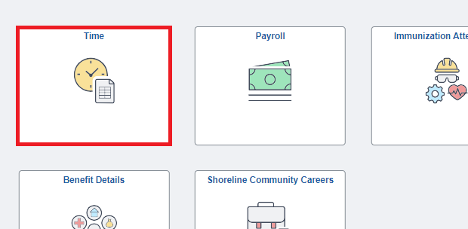

- Click on the Absence Balances Tile
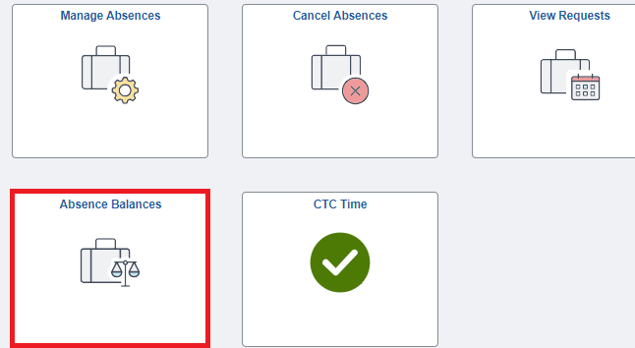

- This page will display your balances.
